Antox X & Antox T
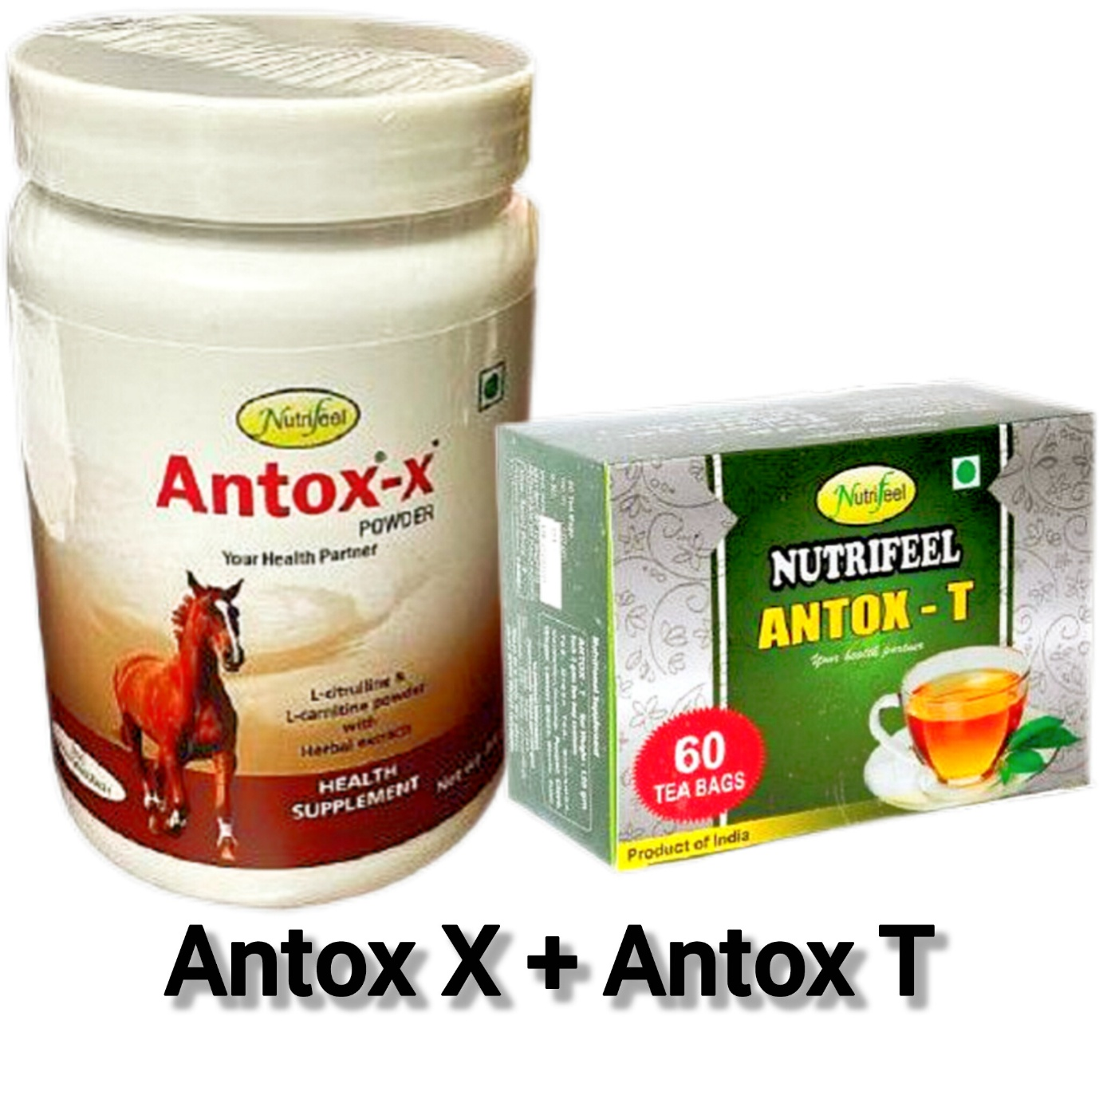

Benefits :
- Helps in controlling mental stress and stress levels.
- Aids in boosting immunity power.
- Helps improve metabolism and maintain electrolyte balance.
- Beneficial for increasing muscle strength.
- Helps in enhancing liver strength.
- Beneficial for increasing natural strength and stamina.
How To Use :
- In 100 ml of milk, add 2 teaspoons of powder (10gm) and take it after dinner.
- Stop drinking regular tea at home, and instead, prepare 5 cups of decoction using 1 tea bag of Antox-T and drink it throughout the day.
Note :
This nutritional product is designed to address nutritional deficiencies in the body, aiding in the recovery from illness.

